Quy Pham
ECE 201 MATLAB
LAB 9
FIR Filtering of Sinusoidal Waveforms
April 20, 2008

% 5.2.1 Freq response of the 3 points averager

% a. Derivation of the freq response of the filter:
% x[n] = A*exp(j*w*n + phi)
% y[n] = 1/3*x[n] + 1/3*x[n-1] + 1/3*x[n-2]
% = 1/3*A*(exp(j*w*n + phi) + exp(j*w*(n-1) + phi) + exp(j*w*(n-2) + phi))
% = 1/3*A*(exp(j*w*n + phi) + exp(j*w*n + phi)*exp(-j*w) + exp(j*w*n + phi)*exp(-j*2*w))
% = 1/3*A*exp(j*w*n + phi)*(1 + exp(-j*w) + exp(-j*2*w))
% H = 1/3*(1 + exp(-j*w) + exp(-j*2*w))
% = 1/3*exp(-j*w)*(exp(j*w) + 1 + exp(-j*w))
% = 1/3*exp(-j*w)*(2*cos(w) + 1)

% b & c
ww = -pi:(pi/200):pi;
H1 = ((2*cos(ww)+1)/3).*exp(-j*ww);
subplot(2,2,1);
plot(ww,abs(H1));
xlabel('w');
ylabel('Magnitude');
title('Question 3');
subplot(2,2,2);
plot(ww,angle(H1));
xlabel('w');
ylabel('Phase');
title('Question 3');
% c
bb = 1/3*ones(1,3);
H2 = freqz(bb,1,ww);
subplot(2,2,3);
plot(ww,abs(H2));
xlabel('w');
ylabel('Magnitude');
title('Question 4');
subplot(2,2,4);
plot(ww,angle(H2));
xlabel('w');
ylabel('Phase');
title('Question 4');

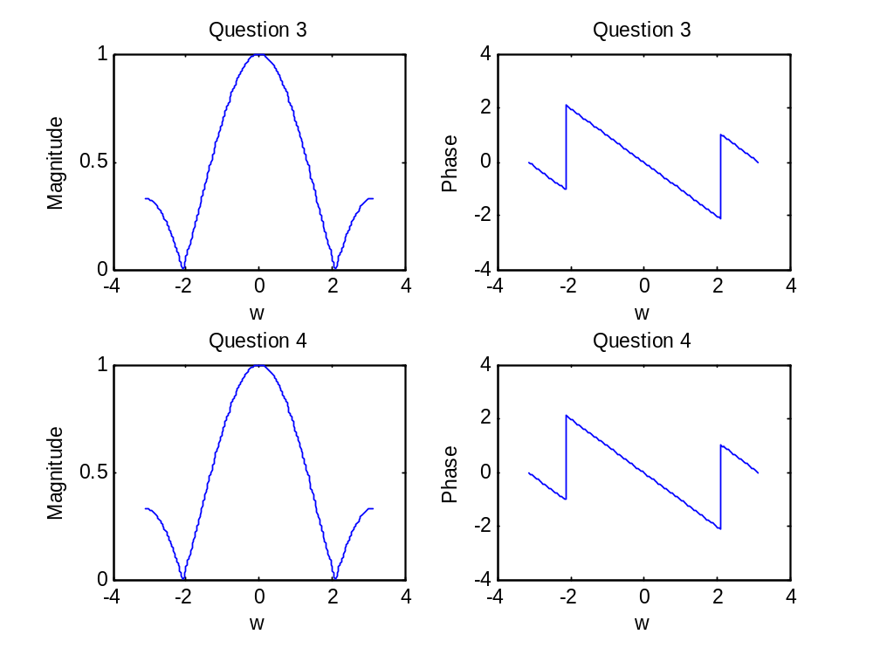

They both result a same figure.

% 5.3.2 First Differnce Filter
A = 7;
phi = pi/3;
w = 0.125*pi;
n = 0:49;
xx = A*cos(w*n + phi);
bb = [5 -5];
yy = firfilt(bb,xx);
% a.
length_yy = length(xx) + length(bb) - 1;
% 51 = 50 + 2 -1
% b.
subplot(2,1,1);
stem(xx);grid;
xlabel('Samples');
ylabel('xx');
title('x[n]');
subplot(2,1,2);
stem(yy);grid;
xlabel('Samples');
ylabel('yy');
title('y[n]');
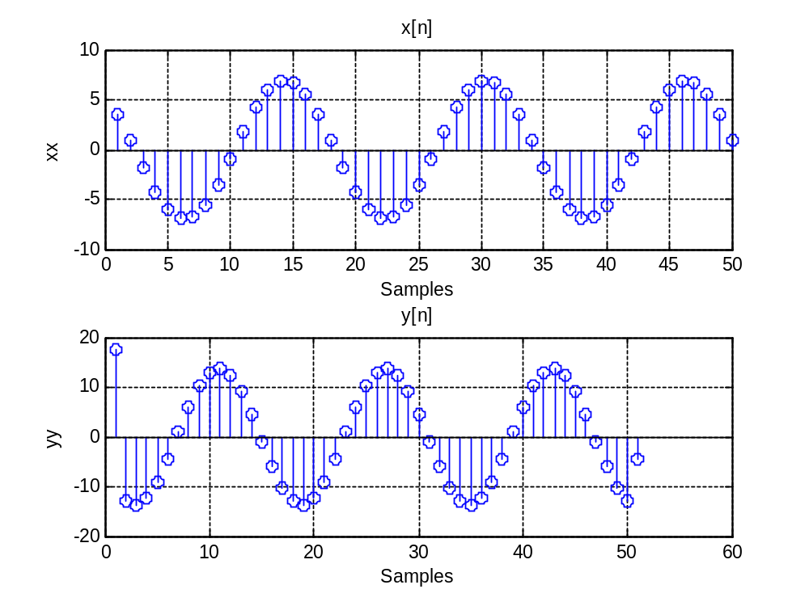
% c.
% Amplitude = 7
% phi = -2*pi*t/T = -2*pi*(-3)/16 = 0.375*pi
% d.
% because at first sample y[0] = 5*x[0] - 5*x[-1]
% x[-1] is undefined so it assumes x[-1] = 0
% so y[0] = 5*x[0] = 5*7*cos(pi/3) = 17.5
% e.
% Amplitude = 14
% Freq f = 1/T = 1/16s = 0.0625 Hz
% phi = -w*t = -2*pi*f*t = -2*pi*0.0625*(-6) = 0.75*pi
% f.
% The relative amplitude: A(rel) = Ay/Ax = 14/7 = 2
% The relative phase: phi(rel) = phi(y) - phi(x) = 0.75*pi - 0.375*pi =
% 0.375*pi
% g.
% Amplitude
abs(5-5*exp(-j*0.125*pi))
% ans = 1.9509
% Phase
angle(5-5*exp(-j*0.125*pi))
% ans = 1.374

% 5.3.3 Linearity of the filter
% a.
A = 7;
phi = pi/3;
w = 0.125*pi;
n = 0:49;
xx = A*cos(w*n + phi);
bb = [5 -5];

xa = 2*xx;
ya = firfilt(bb,xa);
subplot(2,1,1);
plot(n,xa);grid;
title('xa(n)');
subplot(2,1,2);
plot(n,ya(1:50));grid;
title('ya(n)');
% The relative amplitude is: 2
% And the relative phase: 0.375*pi
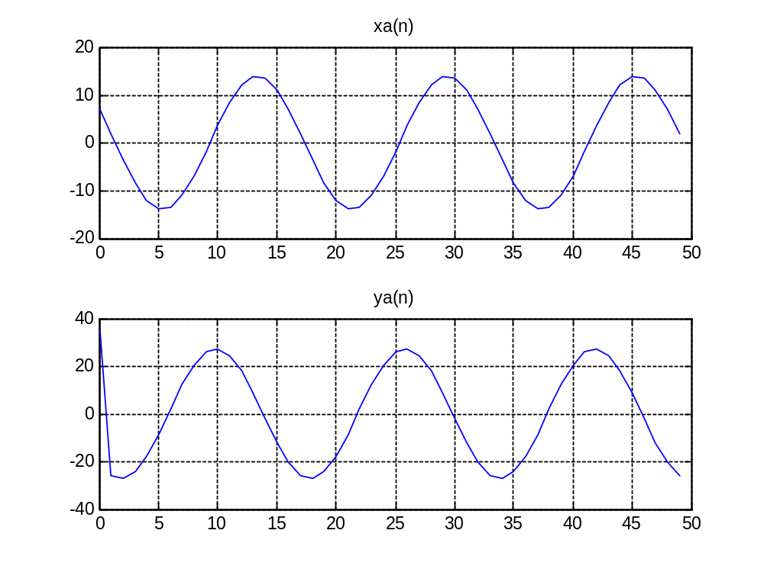
% b.
xb = 8*cos(0.25*pi*n);
yb = firfilt(bb,xb);
subplot(2,1,1);
plot(n,xb);grid;
title('xb(n)');
subplot(2,1,2);
plot(n,yb(1:50));grid;
title('yb(n)');
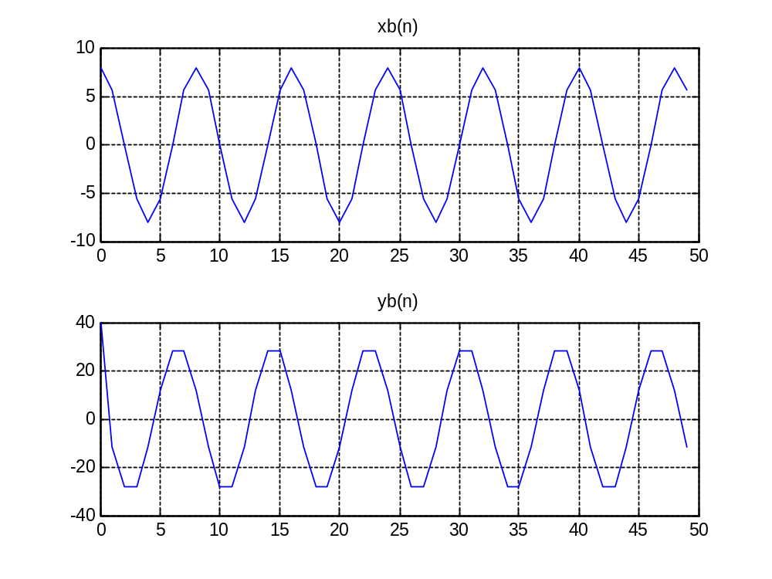
% The relative amplitude A = Ay/Ax = 30/8 = 3.75
% The relative phase = phi(y) - phi(x) = 3*pi/8 - 0 = 0.375*pi
% The amplitude and freq stay the same, only the phase is changed.
% c.
xc = xa + xb;
yc = firfilt(bb,xc);
subplot(2,1,1);
plot(yc);grid;
title('yc(n)');
subplot(2,1,2);
plot(ya+yb);grid;
title('ya(n)+yb(n)');
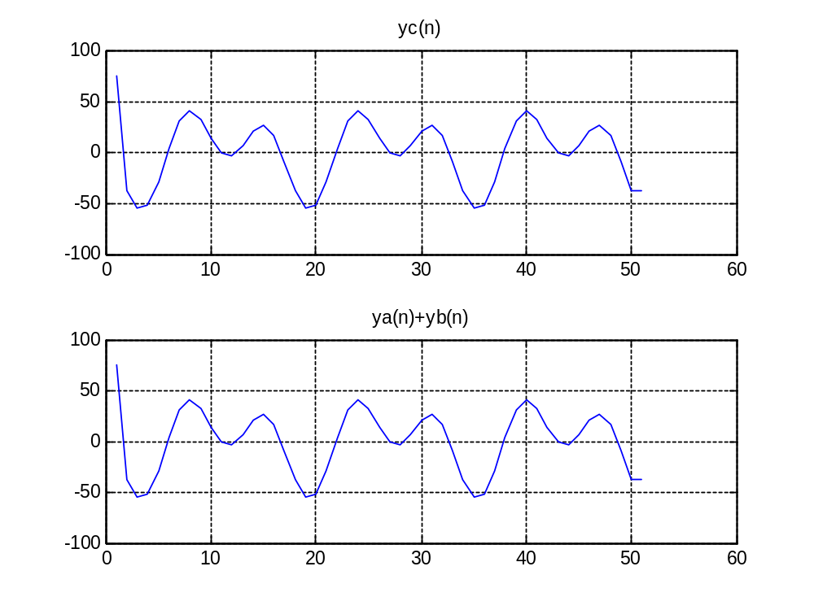
They both look the same. Whether we added first then filter or we filter them then add, both result a same figure.

% 5.3.4 Time-Invariance of the filter
A = 7;
phi = pi/3;
w = 0.125*pi;
n = 0:49;
xx = A*cos(w*n + phi);
bb = [5 -5];
yy = firfilt(bb,xx);

xs = 7*cos(0.125*pi*(n-3)+(pi/3));
ys = firfilt(bb,xs);
subplot(2,1,1);
plot(yy);grid;
title('y(n)');
subplot(2,1,2);
plot(ys);grid;
title('ys(n)');
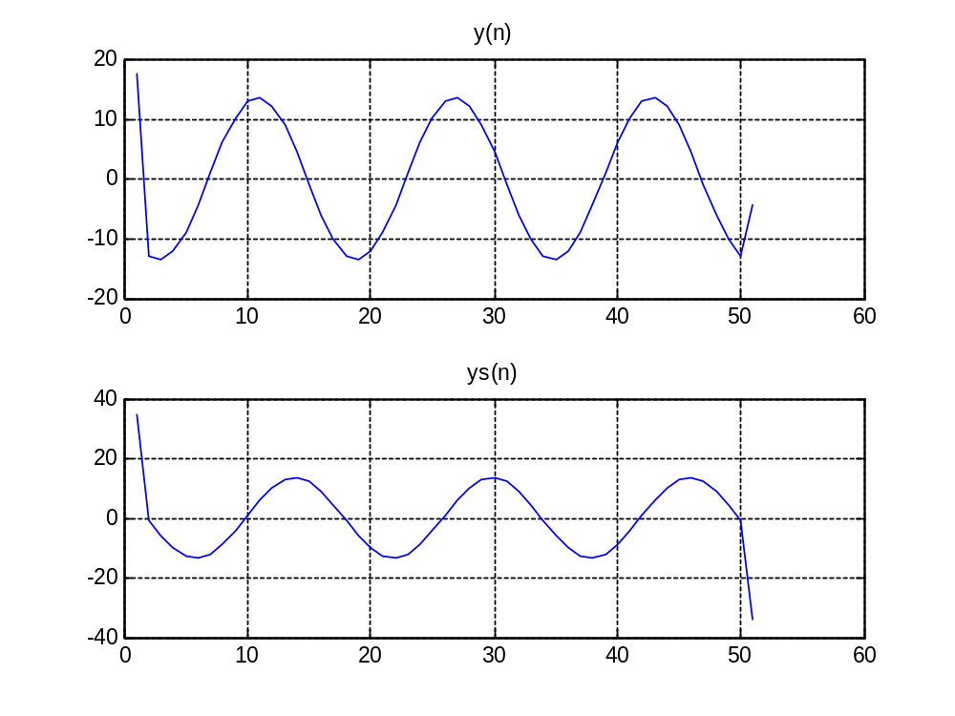
To line up y(n) and ys(n) we need to shift y(n) samples by 3: n = 3:52.

% 5.3.5 Cascading 2 systems
% a.
A = 7;
phi = pi/3;
w = 0.125*pi;
n = 0:49;
xx = A*cos(w*n + phi);

bb = [1 -1];
ww = xx.^2;
yy = firfilt(bb,ww);
% b.
subplot(3,1,1);
plot(n,xx(1:50));grid;
title('x(n)');
subplot(3,1,2);
plot(n,ww(1:50));grid;
title('w(n)');
subplot(3,1,3);
plot(n,yy(1:50));grid;
title('y(n)');
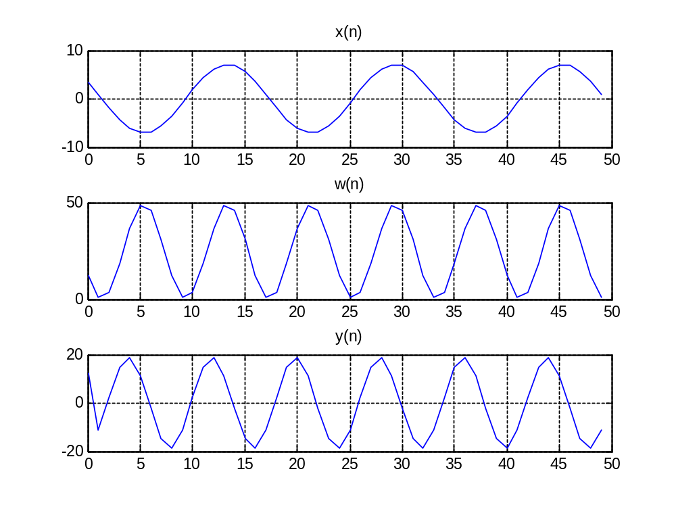
% f.
bb2=[1 -2*cos(0.25*pi) 1];
y2=firfilt(bb2,ww);
mm=0:51;
plot(mm,y2);grid;
title('y2(n)');

